Construction Alert - Coming Soon!

The Facilities Operations Department is pleased to announce the beginning of another phase of improvement for the South Campus - the parking lot between the new Aquatic Center and the Olin Quad.  This improvement includes the construction of a pedestrian connector across the parking lot, as well as traffic calming and landscape enhancements.  During construction, it will be necessary to close certain zones within the parking lot to both pedestrian and vehicular traffic.  This will be done in phases in an effort to minimize inconvenience to the campus community.

Phase-1:  The center north-bound lane will be closed until work in the two red clouded areas is complete.

Phase-2:  The center north-bound lane will be re-opened and the western south-bound lane will be closed until work in the blue rectangular area is complete.

Further up-dates and actual parking lot closing dates will be forthcoming as the final planning and permitting are completed.  We apologize for any inconvenience this may cause and we ask for your help in keeping the areas safe for both the campus community and the construction force that is working to improve our university.

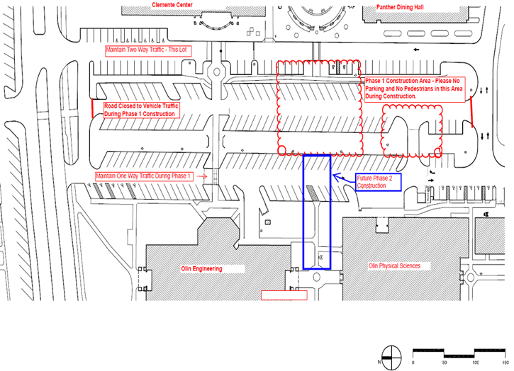

Posted 09/14/2011