Drawing Format Download and Opening Instructions
- Download the Format Files on the Machine Shop Website
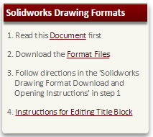
- Open file location
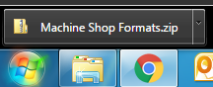

- Copy the following:
C:\ProgramData\SolidWorks\SolidWorks 2012\lang\english

- Extract all Files
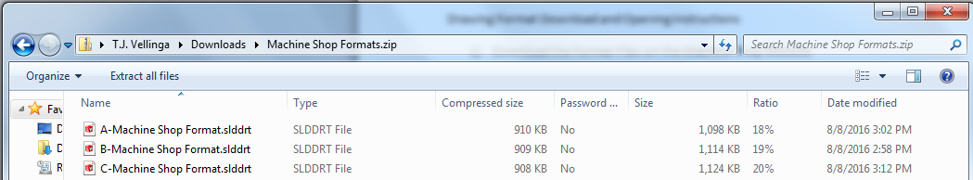

- Paste “C:\ProgramData\SolidWorks\SolidWorks 2012\lang\english” in the text box, push Extract
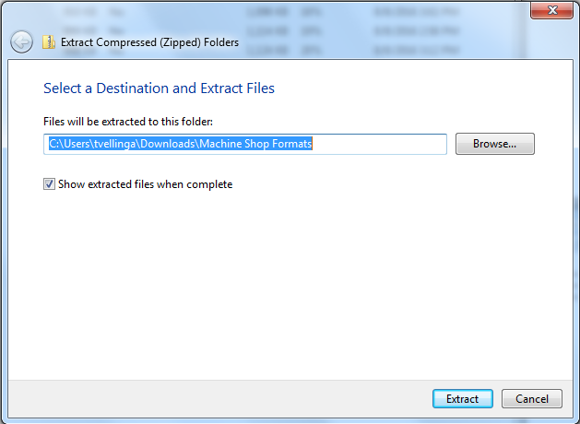

- Open Solidworks

- Create a new document

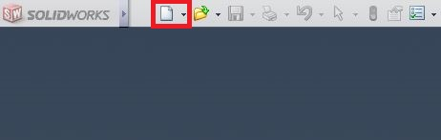

- Select Drawing

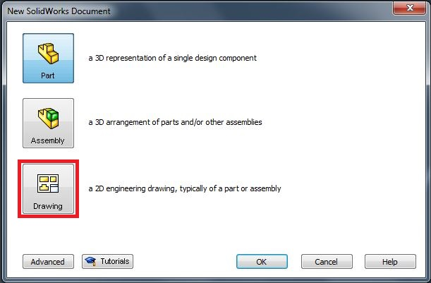 OR 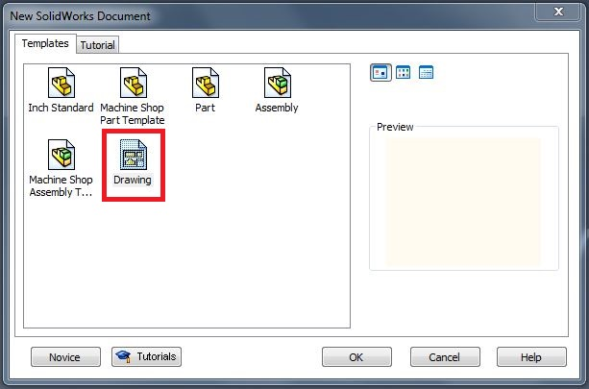

- Scroll down to the bottom where you will see “A-Machine Shop Format.slddrt” “B-Machine Shop Format.slddrt” and “C-Machine Shop Format.slddrt”
If you do not see them unselect the box “Only show standard formats”

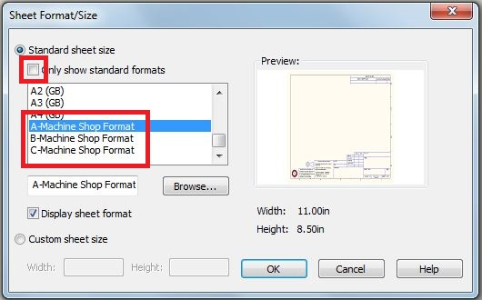

- A-Machine Shop Format is for standard 8.5” X 11”

- B-Machine Shop Format is for standard 11” X 17”

- C-Machine Shop Format is for standard 17” x 22”

- Click OK

