Config.pro Downloading Instructions
- Download Config.pro on www.fit.edu/machine/
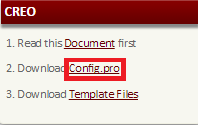
- Open downloaded Config.pro file

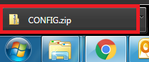

- Extract Config.pro file
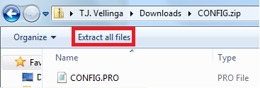
- Copy the following: C:\Users\Public\Documents

- Paste the following: C:\Users\Public\Documents into the prompted box to extract files to.

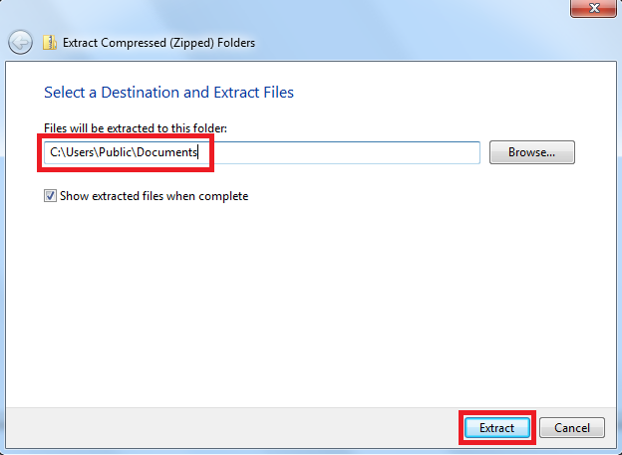
Template Download Instructions
- Download Template Files on www.fit.edu/machine/ website
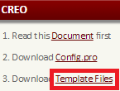
- Open downloaded templates.zip file

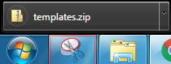

- Extract all files

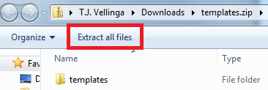

- Copy the following: C:\Users\Public\Documents

- Paste the following: C:\Users\Public\Documents into the prompted box to extract files to.

How to Use Start Part and Drawing Format
- Use the default template when starting a new part

- When starting a new drawing select “Empty with Format” and click the “Browse” button
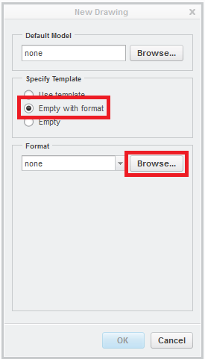

- Select 1 of the 3 drawing formats: a_machine_shop, b_machine_shop or c_machine_shop
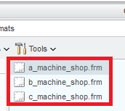

- A size= 8 ½” X 11” B size= 11” X 17” C size= 17” X 22”
- Be sure to have a part attached to each drawing
- To edit the values in the drawing you MUST edit the values in the parameters in the part
Edit this column to edit the drawing values
