Title:
Subtitle

by

[Your Full Name]

A thesis submitted to the [name of college or school] of
Florida Institute of Technology
in partial fulfillment of the requirements
for the degree of

[Degree]
in
[Program]

Melbourne, Florida
Month, Year
We the undersigned committee hereby approve the attached thesis,
“Xxxx Xxxx Xxxxxxxx Xxxxxxxx xxx Xxx Xxxxxxxxxxxx: Xxxxxxxx Xxxxxxxxxx Xxxxxxx Xxxxxxx Xxxxxxxx: Xxxxxx-Xxxxxxle Xxxxxx.”
by
Given Name Middle Name Family Name

_________________________________________________
First Name Family Name, Ph.D.
Assistant Professor
Mechanical and Civil Engineering
Major Advisor
_________________________________________________
First Name Family Name, Psy.D.
Associate Professor
Clinical Psychology
_________________________________________________
First Name Family Name, Ph.D.
Associate Professor
Mechanical and Civil Engineering
_________________________________________________
First Name Family Name, Ph.D.
Assistant Professor
Mechanical and Civil Engineering
_________________________________________________
First Name Family Name, Ph.D., P.E.
Professor and Department Head
Mechanical and Civil Engineering

Abstract

Title: Subtitle
Author: Your Full Name
Advisor: Major Advisor Name, Ph.D.
This document is intended to be used as a template for creating a Florida Tech Thesis or Dissertation. The styles are set to meet the formatting recommendations and the text can be overwritten to create a new document. A key thing to remember in this process is consistency in your formatting.
The abstract is required and is a one-page summary of your work that includes objectives, work performed, key results, and new or unusual information. The abstract is part of the front matter, and page numbering begins here, with “iii,” whether it is the third page or not. Insert a Section Break (from the Page Layout menu) at the end of the signature page to begin numbering the front matter in the footer. Choose Continuous Break if page breaks are built into your Heading 1 style, as they are in this template, or a Next Page break if page breaks are not built into the Heading 1 style (see Figure 1 and Figure 2).

Table 1: Formatting suggestions
Component | Requirement
Headings | Use Styles to maintain consistent formatting. Include an extra space before lower level headings and use Keep with next to avoid lone headings at the bottoms of pages.
Margins | 1.2" Top, Bottom, Right Margins. 1.7" Left Margin.
Spacing | 1.5 is preferred as it is the most readable for theses. Double-spacing is required for dissertations.
Paragraphs | First-line indents are optional. Add extra spacing between paragraphs for block paragraphs or for line spacing below 1.5.
Page Numbering | Insert in footer (front matter) or header (all other pages). Insert a Section Break between front matter and Chapter 1 to allow different numbering formats.
Alignment | Ragged right (unjustified or left-aligned) margins are preferred.
Font | Times New Roman, 11-12 point.

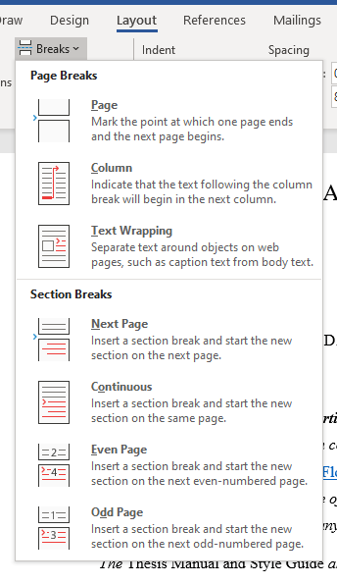
Figure 1: Section Breaks
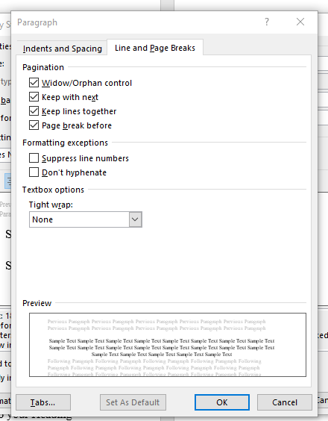
Figure 2: Heading 1 paragraph formatting includes Page break before.

Double-click the footer (in the front matter) or the header (in the main body of the document) to insert page numbers. Choose the Plain option and select Format Page Numbers to choose either lower-case Roman numerals for front matter or Arabic numerals for the main body of the document (see Figure 3). Generally, footer numbering is centered and header numbering is right aligned. Your style for page numbering in the main document can differ if required by your advisor but the front matter must follow the set guidelines.
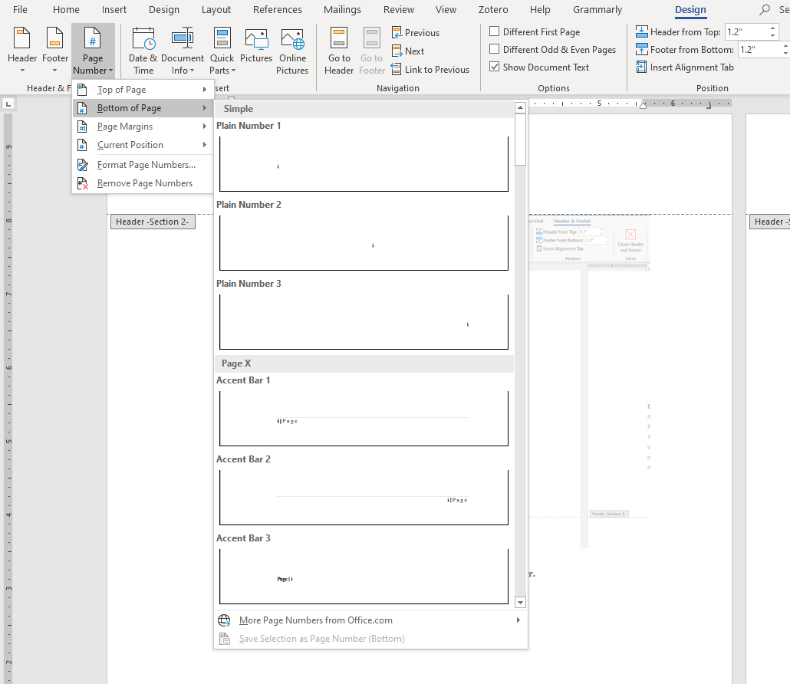
Figure 3: Insert page numbers in the header or footer.

Table of Contents

Abstract iii
List of Figures ix
List of Tables x
Acknowledgement xi
Dedication xii
Chapter 1 First Level Heading 1 1
Second Level Heading 2 1
Second Level Heading 2 2
Second Level Heading 2 3
Third Level Heading 3 4
Chapter 2 First Level Heading 1 6
Second Level Heading 2 6
Chapter 3 First Level Heading 1 7
Second Level Heading 2 7
References 8
Appendix 9
Second Level Heading 2 9

List of Figures

Figure 1: Section Breaks v
Figure 2: Heading 1 paragraph formatting includes Page break before. vi
Figure 3: Insert page numbers in the header or footer. vii
Figure 4: Page Layout, Margin Settings 1
Figure 5: Body Style Settings 2
Figure 6: References Menu 3
Figure 7: List of Figures or Tables 3
Figure 8: Insert Cross-references to images or tables. 4
Figure 9: The Pilcrow 5

List of Tables

Table 1: Formatting Suggestions iv
Table 2: Landscape Page 10

Acknowledgement

The acknowledgement is optional, but typically included as a personal expression of thanks.

Dedication

The dedication is optional, but typically is included as a personal expression of gratitude to one particular person (parent, spouse, sponsor, etc.)
Insert a Section Break at the end of the front matter to begin the numbering of the main document.

First Level Heading 1

Second Level Heading 2
The document should be set to meet the 1.2” margins for the Top, Bottom and Right (see Figure 4). The Left margin is set to 1.7” to allow for potential print binding. The layout for landscaped pages will need to be adjusted to 1.2” for the Bottom, Right and Left margins and 1.7” for the Top margin (see Table 2).
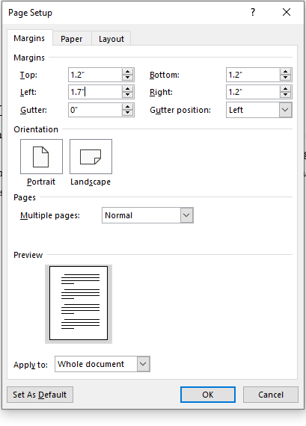
Figure 4: Page Layout, Margin Settings

Second Level Heading 2
Florida Tech master’s theses require spacing of at least single but not more than double, typically 1.5 is used. Dissertations require double-spacing throughout. Block paragraphs (those with no first line indents, as in this template) require extra spacing between/after paragraphs (see Figure 5).
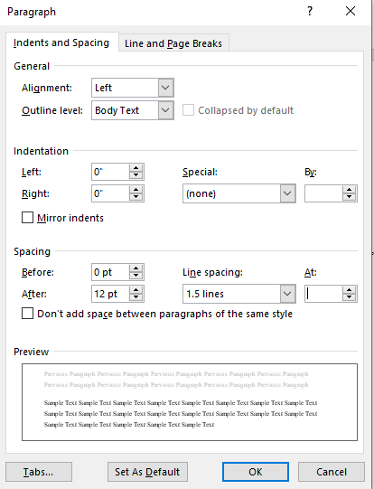
Figure 5: Body Style Settings

Second Level Heading 2
Insert the Table of Contents, List of Figures, and List of Tables from the References menu. To update all tables, figure and table numbers, and cross-references at one time, select all text (Ctrl + a) and then F9 on the keyboard. All the tools you need for creating your Table of Contents, List of Figures, List of Tables, and Cross-references are available in the References menu (see Figure 6).
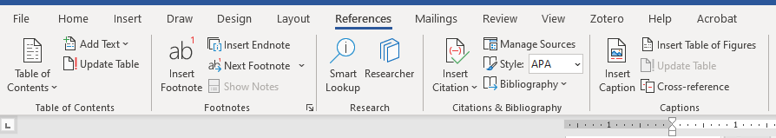
Figure 6: References Menu
In the Table of Figures dialog box, choose either Figure or Table from the Caption label to differentiate between the two (see Figure 7).
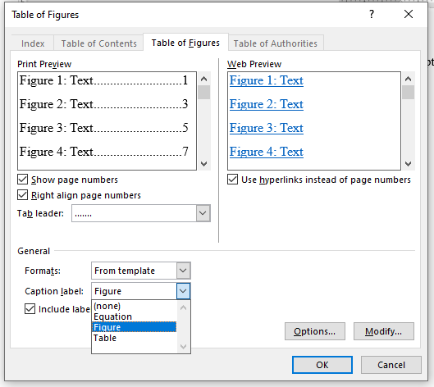
Figure 7: List of Figures or Tables
Right-click images or tables and select Insert Caption to number and label automatically or select Insert Caption from the References menu. When referring to images or tables in the text, choose Cross-reference from either the Insert menu or the Reference menu (see Figure 8).
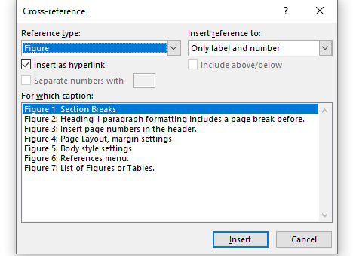
Figure 8: Insert Cross-references to images or tables.
If your document includes equations that need to be numbered and cross-referenced the above tool can be used for those as well. Simply choose Equation from the Caption label.

Third Level Heading 3
Work with your advisor and the Office of Graduate Programs throughout the process of writing and formatting your thesis.

Helpful Tip:
Clicking the pilcrow (¶) symbol in the Home menu reveals hidden formatting and spacing within your Word document (see Figure 9).
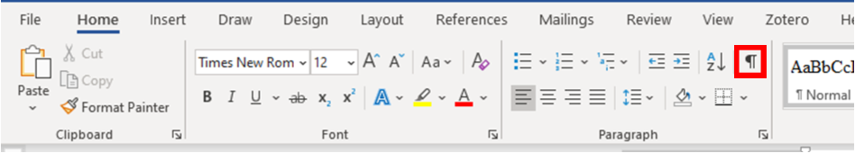
Figure 9: The Pilcrow

First Level Heading 1

Second Level Heading 2
Body text. Body text. Body text. Body text. Body text. Body text. Body text. Body text. Body text. Body text. Body text. Body text. Body text. Body text. Body text. Body text. Body text. Body text. Body text. Body text. Body text. Body text. Body text. Body text.
Body text. Body text. Body text. Body text. Body text. Body text. Body text. Body text. Body text. Body text. Body text. Body text. Body text. Body text. Body text. Body text. Body text. Body text. Body text. Body text. Body text. Body text. Body text. Body text.
Body text. Body text. Body text. Body text. Body text. Body text. Body text. Body text. Body text. Body text. Body text. Body text. Body text. Body text. Body text. Body text. Body text. Body text. Body text. Body text. Body text. Body text. Body text. Body text.

First Level Heading 1

Second Level Heading 2
Body text. Body text. Body text. Body text. Body text. Body text. Body text. Body text. Body text. Body text. Body text. Body text. Body text. Body text. Body text. Body text. Body text. Body text. Body text. Body text. Body text. Body text. Body text. Body text.
Body text. Body text. Body text. Body text. Body text. Body text. Body text. Body text. Body text. Body text. Body text. Body text. Body text. Body text. Body text. Body text. Body text. Body text. Body text. Body text. Body text. Body text. Body text. Body text.
Body text. Body text. Body text. Body text. Body text. Body text. Body text. Body text. Body text. Body text. Body text. Body text. Body text. Body text. Body text. Body text. Body text. Body text. Body text. Body text. Body text. Body text. Body text. Body text.

References

Author, B. C., & Author, D. (2014). Title of the article. Title of the Journal, Vol(issue), pages.
Barber, B. C., & Author, E. (2014). Title of the article. Title of the Journal, Vol(issue), pages.
Carver, B. C., & Author, F. (2014). Title of the article. Title of the Journal, Vol(issue), pages.
Daughter, B. C., & Author, G. (2014). Title of the article. Title of the Journal, Vol(issue), pages.

Appendix

Second Level Heading 2
The appendix is used to include raw data, hard computer codes, tables, letters, surveys, examples, questionnaires, etc.
Table 2 demonstrates how landscape pages should appear within your document. Landscape pages are intended to be used when your table or figure is too large to fit within the margins of a portrait page. They can be used in the body of your document but require Section Breaks to differentiate the style from the rest of your document.

Table 2: Landscape Page
