- Click on My Studies.

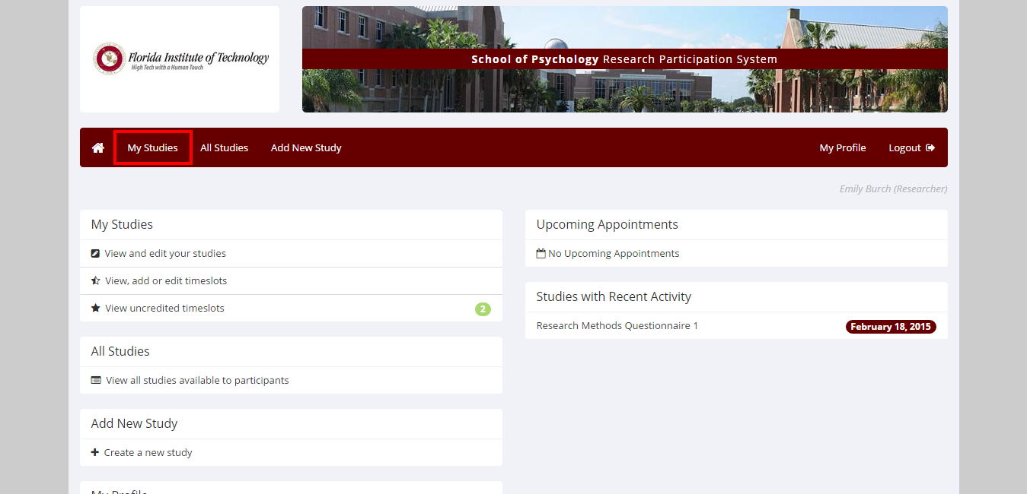

- You may see uncredited timeslots for participants whose names have not yet shown up on your online survey data - This refers to students who have signed up to take your survey, but have not yet done so. Most students complete the survey once they sign up, but they have until the date you chose to complete it and many will wait. You will receive a notification every 24 hours at 5pm EST saying that there are uncredited timeslots; however, DO NOT credit participants who have not yet taken the survey.

- Click on Modify.

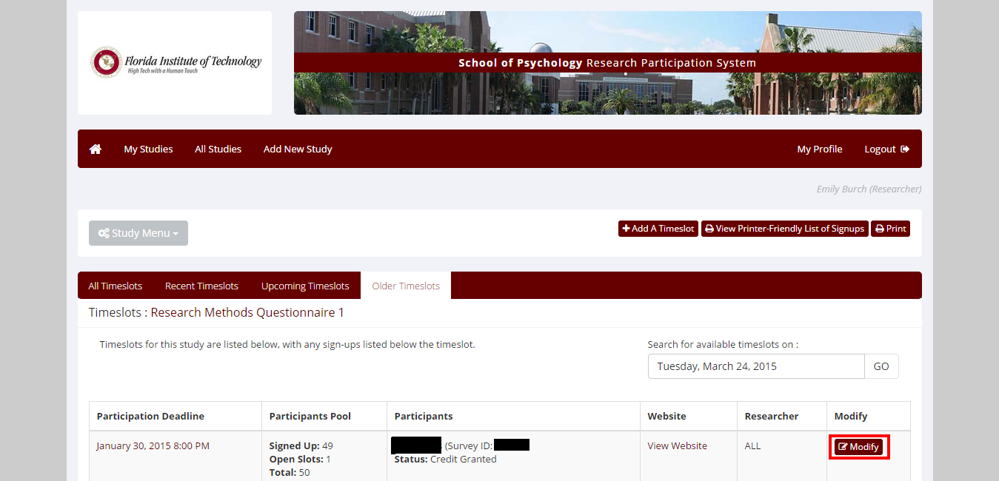

- Choose an option:
Participated, if individual completed the survey.
Excused no-show, if individual has not completed the study within your set deadline, and you want the individual to be able to sign up for your study again in the future.
Unexcused no-show, if individual has not completed the study within your set deadline, and you want the individual to not be able to sign up for your study in the future.

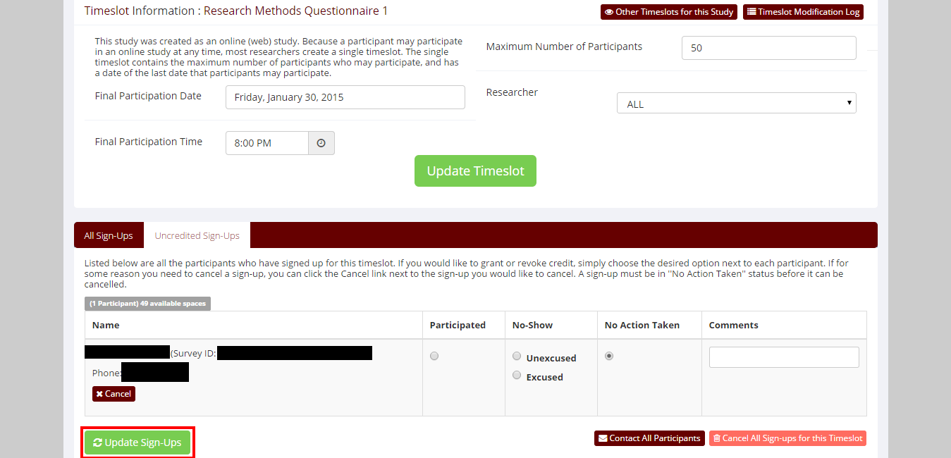

- Click Update Sign-Ups.

