Editing Drawing Title Block
- The drawing title block is not edited in the drawing but in the PART FILE
  - DO NOT EDIT THE DRAWING TITLE BLOCK IN THE DRAWING

- Open the part of the drawing you wish to edit

- Click on “File Properties” icon at the top of screen

- Choose “Custom” sub-category
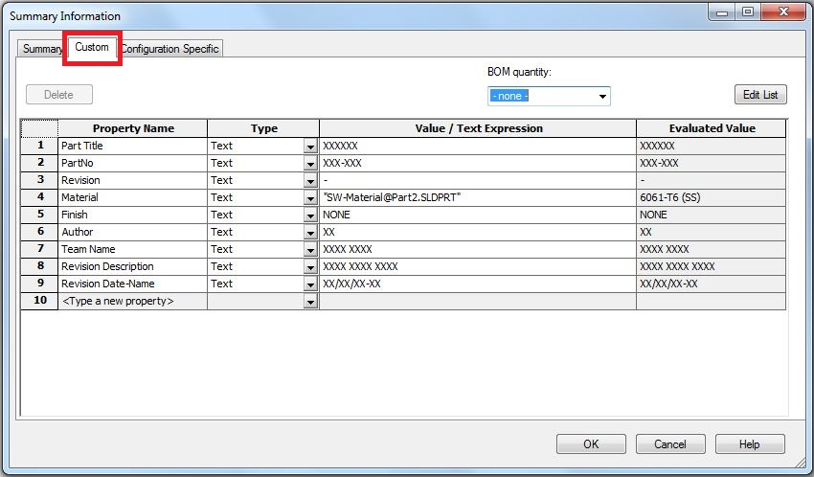
- ONLY edit the text in the “Value/Text Expression” column to the text you want to display in the title block of the drawing
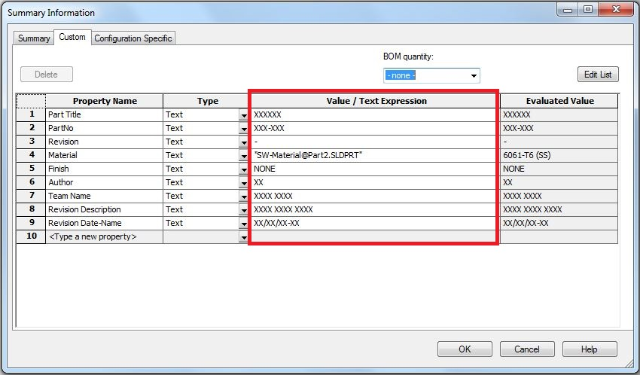

Change the material from Aluminum 6061-T6
- Right click the 6061-T6 (SS) at the top of the design tree
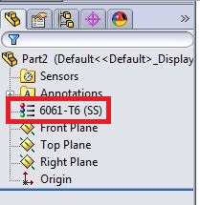

- Click on “Edit Material”
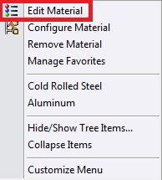

- Choose the material you wish to use from the following window that pops up
