**Florida Tech Staff Advisory Council**

**Meeting Minutes**

**Wednesday, November 6, 2024**

**9am – Board of Trustees Room**

**Present:** Jessica A., Kimberly R., Adam P., Kevin B., Brian D., Jamie B., Stephen VB., Rachel D., Deanna P., Grace G., Jennifer N., Angel P., Norm C., Ann Marie K., Sonny C., Michelle N., Martin G., Dory S., Jennifer N., Rebecca C., Kyler D., Jason G.

**Not Present:** Jeff R., Courtney M., Pat F., Tina E., Yesenia N.

**Additional Guests:** N/A

9:02 am Call to order

(No Guest Speaker)

9:04 am Subcomittees

* **Outreach Subcommittee** – Chair Jennifer Nessmith
  + Faculty Staff Halloween Social – event feedback/ideas for next year
    - Photo gallery is updated, e-mail announcement is ready to be sent
  + Suggestions for next year:
    - Track attendance through Engage QR or wristbands
    - Electronic Voting/crowd voting (connect to pre-sign up of costume contest)
    - New voting categories: Funniest Costume
    - More faculty engagement
    - Better lighting/spotlight was blinding in certain areas
    - No animal rule enforcement (only service dogs allowed/no therapy dogs) – Grace will look into policies for next year
* **Membership Subcommittee** – Chair Deanna Perez
* **Communications Subcommittee** – Chair Kimberly Ryan
  + Meeting this month for website updates
* **Benefits Subcommittee** – Chair Jason Griggs
  + Hank Hughes award nominations form is live and on the website
* **Safety & Security Subcommittee** – Chair Sonny Cherrito
  + Security would not like to be involved with the Safe Ride program, it will need to be student run by Student Life

9:26 am

* **Online Suggestion Box**
  + 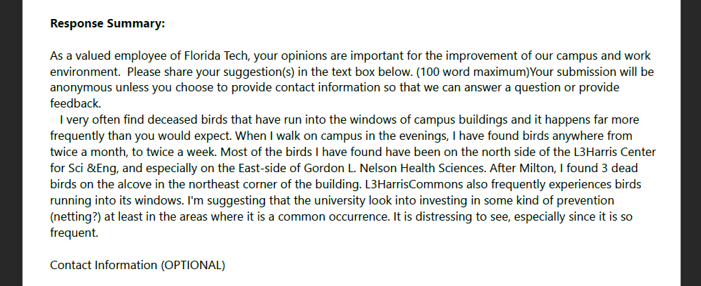**Submission from 10/23/24:**  
    **1**. Issue with birds flying into buildings
  + Facilities will be alerted to get involved with this issue
  + We have appearance standards that need to be met when making building adjustments regarding nets

1. Question on excess vacation time

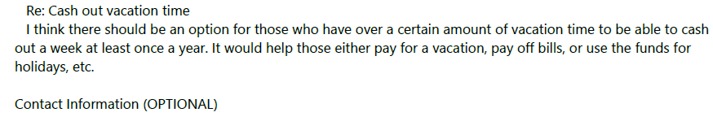

* + Will be brought up to the CFO
  + Some companies allow a percentage to be paid out, not the full amount
    - Suggestion that if you have hours over the max rollover, those could be cashed out, or if you have been here over x years
  + Feedback that not everyone has a role where they can take a full week vacation
* **Old Business and Follow Up:** 
  + Kickball – 11/7
    - If rained out it will be moved to 11/14
  + United Way Campaign!
    - Has closed, but we do not have numbers yet
* **New Business and Other Items:**

* + **Guest Speakers for 2024-2025**
    - Dr. John Nicklow – President
      * + 5/14 Confirmed
    - Wes Sumner – External Affairs & Strategic Advisor to the President
      * + Spring
    - Kimberly Williams – CFO
      * + Spring
    - Allie Biagioni – Events & Protocol
      * + ~~Fall~~ Requested to change to January
    - Kevin Cloos – Facilities
      * + Fall – December
        + Suggestions for speakers

Faculty Senate leader

Dean of Libraries (they will be returning to after hours events)

9:45 am

**Adjourn**

**Next Full Staff Advisory Council Meeting is Scheduled 12/4/2024**