Project Name | Detecting and Measuring Rotten Apples
Team Lead: | Angel Star
Team Member(s): | Conor Pommer, Hussam Al Ghamdi
Faculty Advisor: | Dr. Marius Silaghi, Dept. Of Computer Science, Florida Institute of Technology
**Do not change font size or text color above this message/delete this before completion. The category will be put in by Staff after submission **
Project Description:
Our project, the "Rotten Apple Analyzer," employs artificial intelligence to enhance the detection and classification of rotten apples, thereby aiming to improve the quality of apples distributed in supermarkets. At the heart of our solution is the utilization of the Segment Anything Model (SAM), developed by the META Research program, which facilitates the segmentation of uploaded apple images for detailed analysis.
Design Problem Statement:
The primary challenge addressed by our project is the efficient and accurate identification of rotten or bruised sections in apples, a task that remains labor-intensive and prone to human error. Traditional methods fail to consistently meet the demand for high-quality produce due to the subjective nature of visual inspections.

Major Challenges:
Implementing an AI-based solution posed several challenges, including the development of a reliable method for detecting rotten segments directly from images. Initial attempts to utilize conventional databases proved time-consuming and memory intensive. Additionally, maintaining the SAM model's accuracy with each GUI update and refining the masking process to accurately assess the condition of an apple presented significant hurdles.
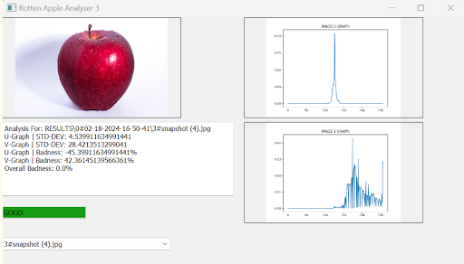
Solution Methods:
To overcome these challenges, we integrated the SAM model for its dynamic adaptability and superior image segmentation capabilities. By segmenting images into masks, our software analyzes these to determine the apple's quality, presenting results through an intuitive GUI that includes visual representations, color distribution graphs (U and V graphs), a numerical rating, and a categorical "Good/Bad" rating. Our approach significantly enhances the speed and precision of quality assessments.

Data Analysis:
The project involved collecting a dataset of green apples and monitoring their degradation over three months to capture the various stages of rot. This empirical data, analyzed through our software, facilitated the refinement of the SAM model's parameters for more accurate rot detection, contributing to the continuous improvement of our algorithm's precision.

Summary Sentence:
The Rotten Apple Analyzer represents a significant advancement in the quality control of apples, leveraging AI to reduce reliance on manual inspections and improve the accuracy of rot detection.

