Project Name | Topographic Exploration Cave Vehicle (TEC-V)
Team Lead: | Michael Dowling
Team Member(s): | Michael Dowling, Zealand Brennan, Stephen Coster, Gabor Papp, Henry Hill
Faculty Advisor(s): | Dr. Marius Silaghi, Dept. of Electrical Engineering and Computer Science, Florida Institute of Technology

Project Description:
The Topographic Exploration Cave Vehicle (TEC-V) project is an endeavor aimed at advancing the capabilities of underwater exploration with a specialized focus on detailed cave mapping. Confronting the intricate design problem of navigating and mapping submerged cave systems, our team tackled several major challenges, including the development of a software interface for real-time data visualization and the integration of sonar technology for environmental scanning.

Innovative solution methods were employed, leveraging the Python programming language for sonar data acquisition and JavaScript for rendering the 3D visual interface. We introduced data analysis techniques to process telemetry and sonar information, translating raw measurements into an interactive three-dimensional cave model. This model enables comprehensive understanding and navigation of the cave’s inner workings.

The TEC-V project goal was to utilize data analysis and the implementation of a user-friendly Cloud Plot web application. The project underscores the feasibility of remote aquatic research. Future work anticipates the refinement of autonomous navigation algorithms and further integration with various sonar data formats, broadening the scope and application of this technology within marine sciences and beyond.

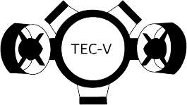
Cloud Plot Webpage: Transposed Data:
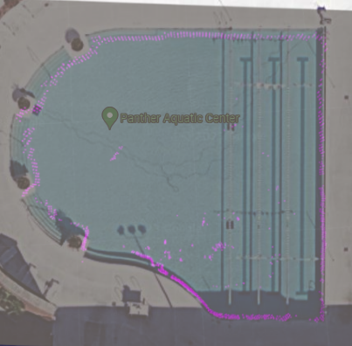
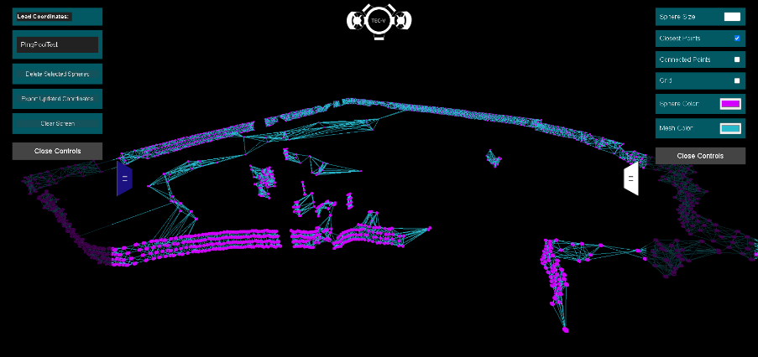

Figure 1: Cloud Plot Scan of Clemente at Florida Tech.
Figure 2: Vertically transposed data points over Google maps image of Clemente Pool.

Team Logo:

